Deployment documentation

1. Introduction
This document outlines the procedures for deploying and operating the IoT Soil Monitoring System developed by Group 7. It includes guidance on hardware assembly, software configuration, network setup, Raspberry Pi integration, and verification processes. The objective is to facilitate the reliable replication and operation of the system across various agricultural sites or testing environments.
2. System Components
Category | Components
Microcontroller | ESP32 DevKitC
Sensor | 7-in-1 RS485 Modbus Soil Sensor
Interface Module | RS485 to TTL Converter
Display | 16×2 LCD with I2C interface
Power Supply | 12 V DC adapter (for sensor) and 5 V USB (for ESP32 + LCD)
Data Hub | Raspberry Pi 4 Model B running Mosquitto MQTT Broker
Enclosure | Custom 3D-printed housing for ESP32 and RS485 module
Software
  Arduino IDE, ESP32 Firmware, Mosquitto Broker, Oracle APEX API, AgriSense V2 Dashboard

3. Pre-Deployment Requirements
- Hardware
  - ESP32 DevKitC board
  - RS485 Modbus soil sensor
  - RS485 converter module
  - 16×2 I2C LCD screen
  - 12 V DC power supply (2 A minimum)
  - USB data cable (for ESP32 upload and power)
  - Breadboard and jumper wires
- Software
  - Arduino IDE (v2.0 or later)
  - ESP32 board package installed
  - Required libraries: WiFi.h, PubSubClient.h, ModbusMaster.h, Wire.h, LiquidCrystal_I2C.h
  - Mosquitto Broker installed on Raspberry Pi
  - Internet connection for firmware upload and API access

4. Hardware Deployment
4.1 Circuit Assembly
- ESP32 → RS485 Module
  - TX → DI
  - RX → RO
  - DE → GPIO 5
  - RE → GPIO 4
  - GND (shared with sensor and 12 V adapter)
- RS485 Module → Soil Sensor
  - A+ → Yellow wire
  - B– → Blue wire
  - VCC → 12 V supply
  - GND → Common ground
- ESP32 → LCD Display (I2C)
  - SDA → GPIO 21
  - SCL → GPIO 22
  - VCC → 5 V (VIN)
  - GND → GND
Ensure all grounds are joined. Place components inside the 3D-printed enclosure, leaving sensor leads outside for soil insertion.

5. Firmware Deployment
- Connect the ESP32 to your computer using a USB data cable.
- Open Arduino IDE.
- Select Board: ESP32 Dev Module.
- Select the correct Port under Tools > Port.
- Copy the provided firmware code into a new sketch.
- Update Wi-Fi credentials:
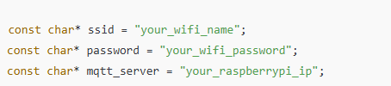
- Click Verify to compile and Upload to flash the code.
- Open Serial Monitor (Ctrl + Shift + M) to confirm successful startup and Wi-Fi/MQTT connection.
6. Raspberry Pi Deployment
- Power on the Raspberry Pi and ensure it is on the same network as the ESP32.
- Update and install Mosquitto:
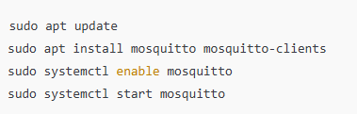
- Verify the broker is active:
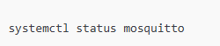
- Confirm port 1883 is open using:
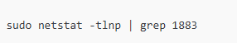
- Take note of the Pi’s IP address:
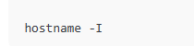

- Insert that IP address in your ESP32 firmware under mqtt_server.
- Use a test command to view incoming data:
7. Database and API Deployment
- The Raspberry Pi sends data to the Oracle APEX API endpoint:
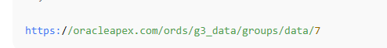
- Ensure outbound internet access is enabled on the Pi.
- Verify that each JSON payload from the ESP32 is correctly formatted before reaching the endpoint.
- The Data Management team’s server stores and exposes this data for the AgriSense V2 dashboard.

8. Frontend Dashboard Connection
The AgriSense V2 dashboard (developed in React + TypeScript) fetches data directly from the Oracle APEX API.
Deployment steps:
- Open the project directory and run:
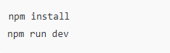
- Update API URL in apiService.ts to:
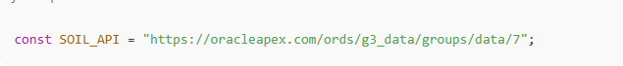
- Start the app and verify live charts update as new MQTT data is published.

9. Calibration During Deployment
- Insert the sensor into soil samples with known moisture and pH values.
- Observe readings on the Serial Monitor and adjust constants if needed:
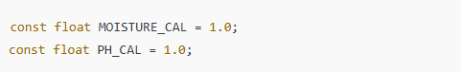
- Example: if the sensor shows 18% but true value is 20%, set MOISTURE_CAL = 1.1;
- Re-test until readings are within ±5 % accuracy.
- Save and re-upload firmware once calibration is complete

10 . Testing and Verification
Step | Expected outcome
Power on system | LCD displays “Soil Sensor Init” then shows live readings
Wi-Fi connection | ESP32 prints “Connected ” with IP address
MQTT publish | Data visible on Pi via mosquitto_sub
API update | JSON data received at Oracle APEX endpoint
Dashboard view | Charts update with live soil values
Sensor accuracy | Readings within ±5 % of reference measurements

11. Maintenance After Deployment
- Keep sensors clean and avoid full submersion in water.
- Check wiring and connectors monthly.
- Restart Raspberry Pi periodically to clear cached data.
- Re-calibrate sensors every 3 months for accuracy.
- Replace power supply if voltage drops below required levels.
Issue | Cause | Solution
No data on LCD | Loose I2C connection | Check SDA/SCL pins
“Read Error!” message |  | Verify A+/B– polarity and shared ground
  Modbus communication failure
No Wi-Fi connection | Wrong SSID/password | Update firmware credentials
MQTT not connected | Broker offline or wrong IP | Restart Mosquitto and check Pi IP
API not updating | Network issue on Pi | Test with ping oracleapex.com and restart service

13. Deployment Verification Checklist
- ESP32 firmware uploaded and running
- RS485 sensor connected and reading data
- LCD display shows valid values
- MQTT broker running on Raspberry Pi
- API endpoint receiving data
- Dashboard fetches live updates
- Calibration complete and verified
14. Conclusion
The IoT Soil Monitoring System utilises straightforward hardware assembly alongside robust open-source software. Once properly configured, it provides precise soil data to the cloud for real-time monitoring and analysis. This system can be readily replicated across various farms, scaled to accommodate multiple sensors, and integrated with irrigation systems to facilitate precision agriculture and optimise resource management.

